SOLUTIONS ARCHITECTING ON CLOUD

(20CS3235AA)

Labs-6

Name: K. VENKATA SREE SAI

ID:2000030439

Part-1

Create and mount an Amazon EFS file system using Amazon

EC2 Launch Instance Wizard

Step-1: Go to Google Browser and type [AWS (Amazon Web Services) Management Console.](https://aws.amazon.com/console/)

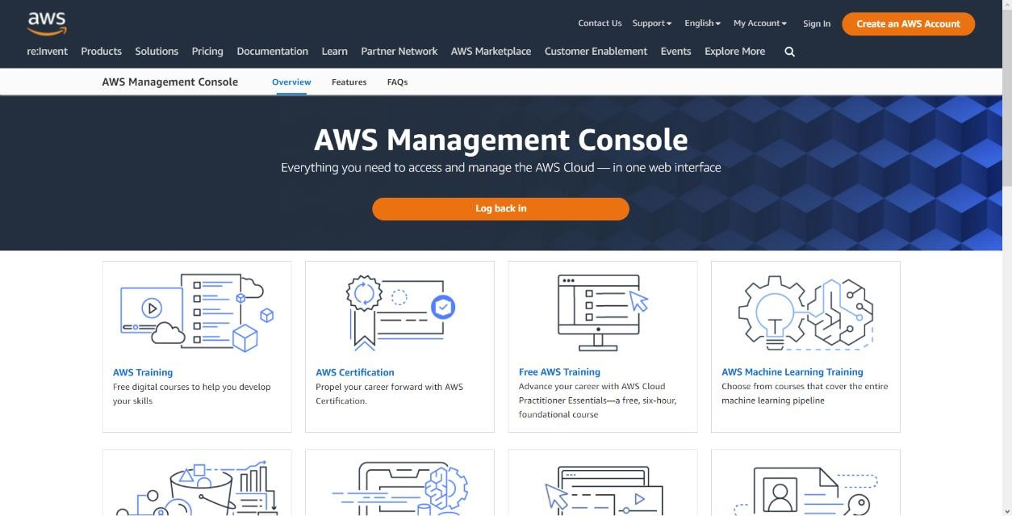

Step-2: After That If you having an account in [Aws management console](https://aws.amazon.com/console/) then click on [Sign-in](https://bit.ly/3WyxeaF) option.

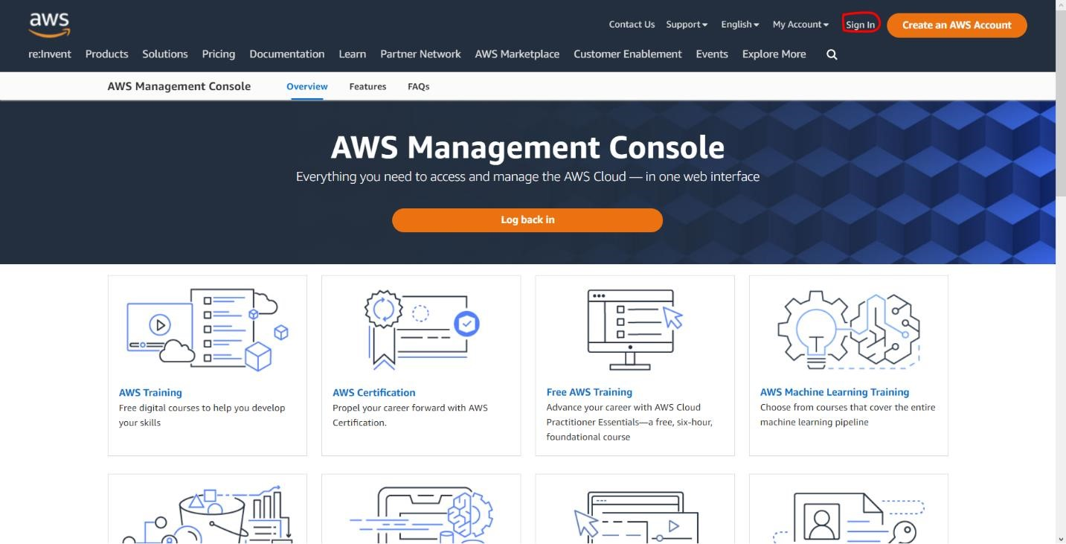

Step-3: After it will redirect to [aws sign-in](https://bit.ly/3WyxeaF) portal.

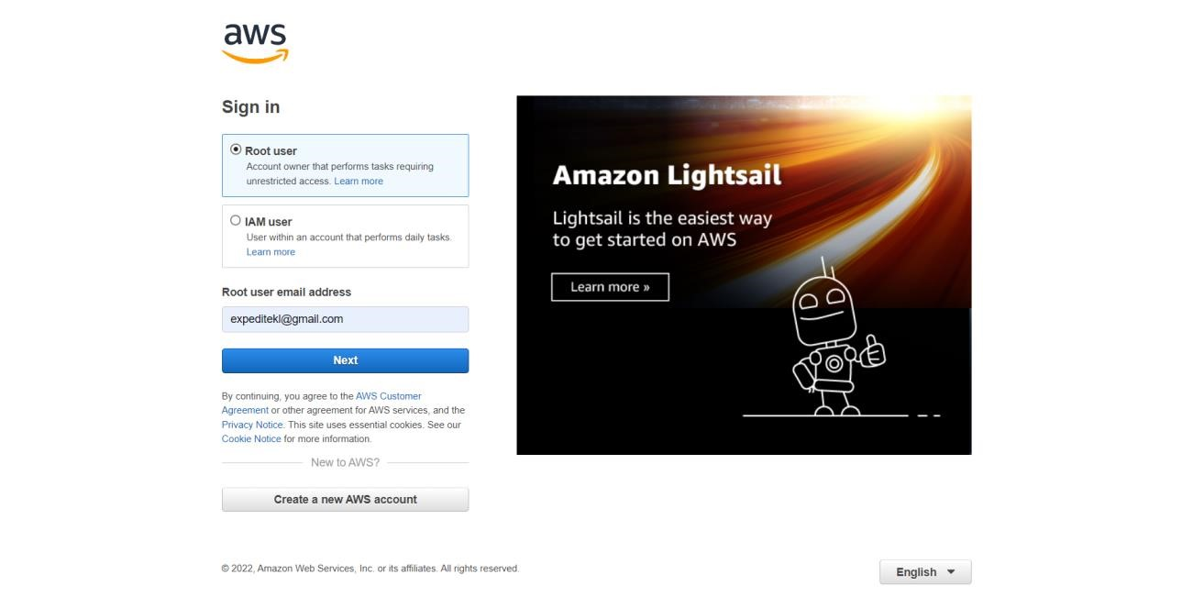

Step-4: Sign-in with your root account only

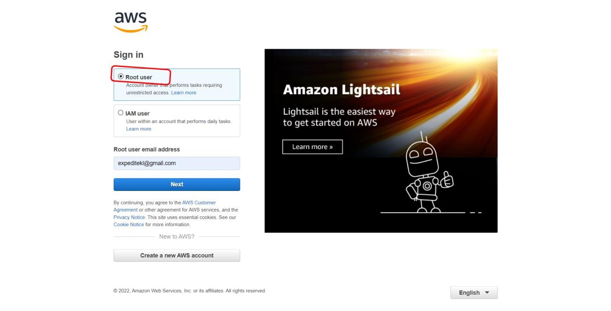

Step-5: After Sign-in the aws management console look like the below image.

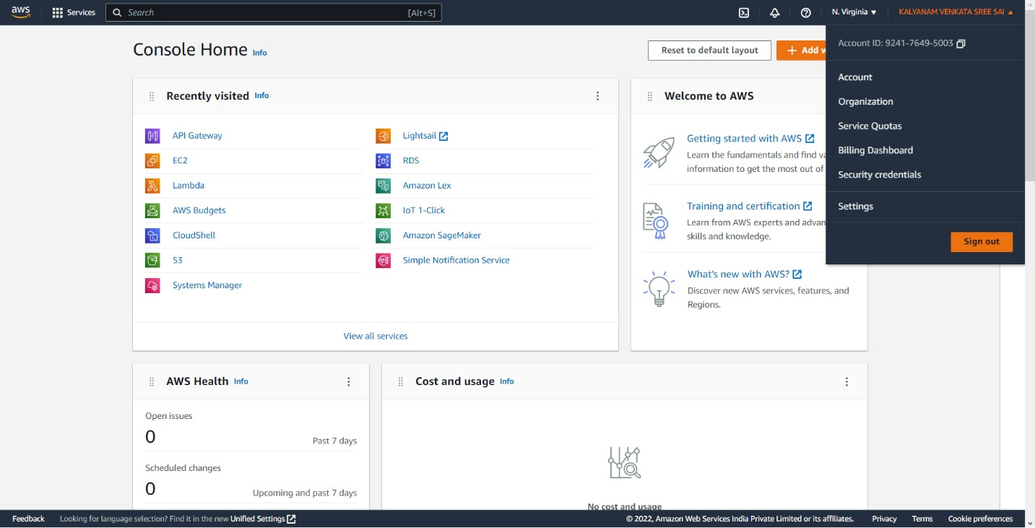

Step-6: Go through the search bar and type “EFS”.

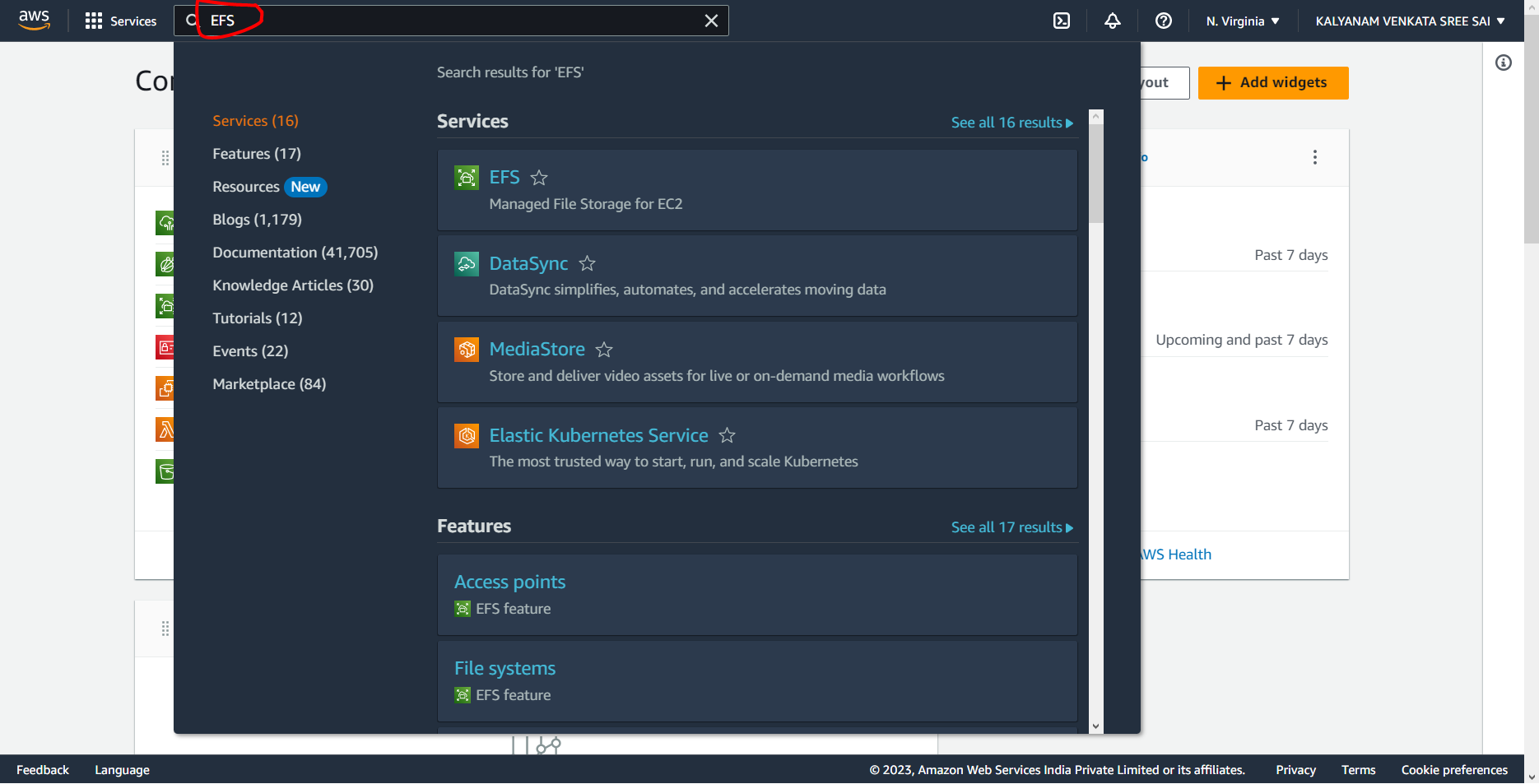

Step-7: Select the First service from the listed below.

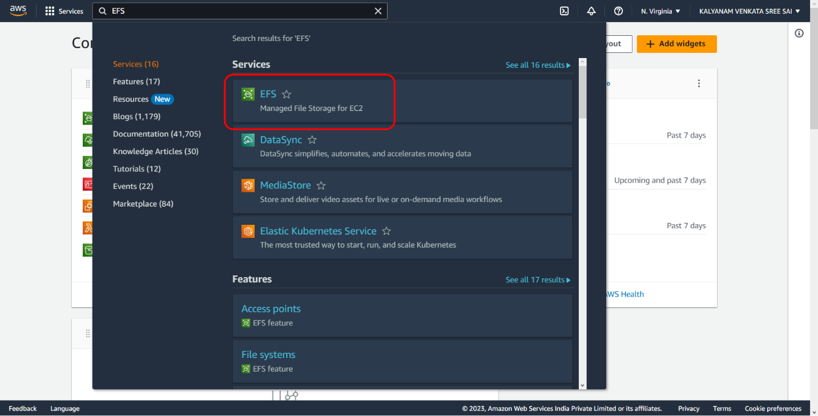

Step-8: After clicking the First Service The console will look like.

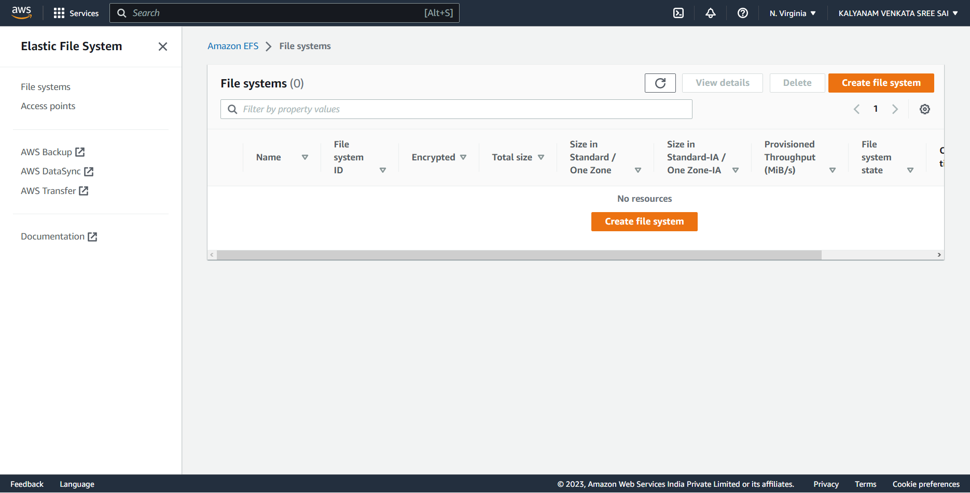

Step-9: Click on the “Create File Systems” in the EFS console.

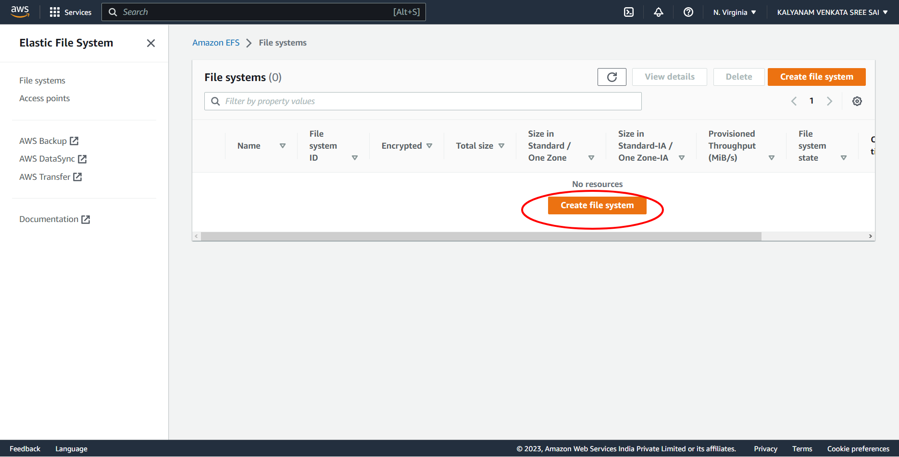

Step-10: Click on the “Create File Systems” Name the File System “LAB-06” and Select the VPC as Default.

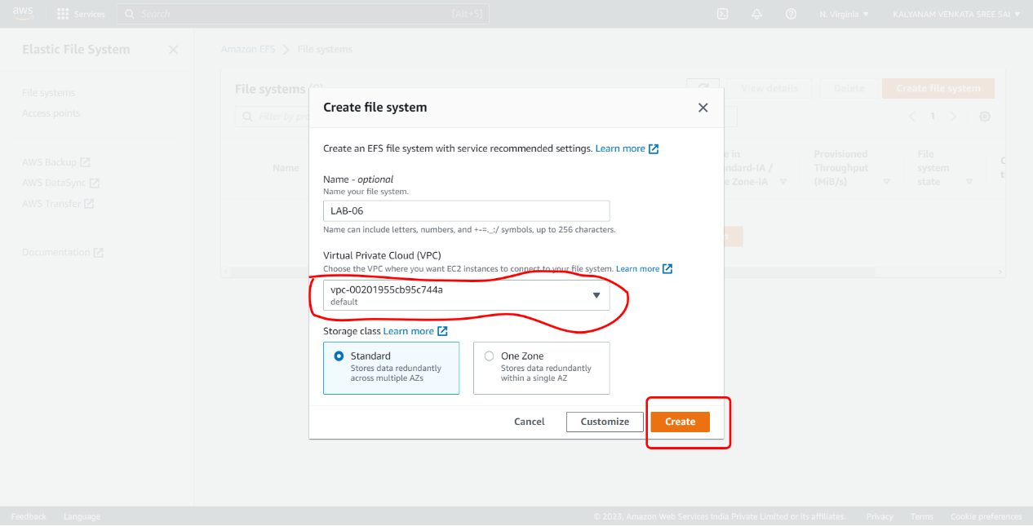

Step-11: After that Clicking on the “Create”, it will look like.

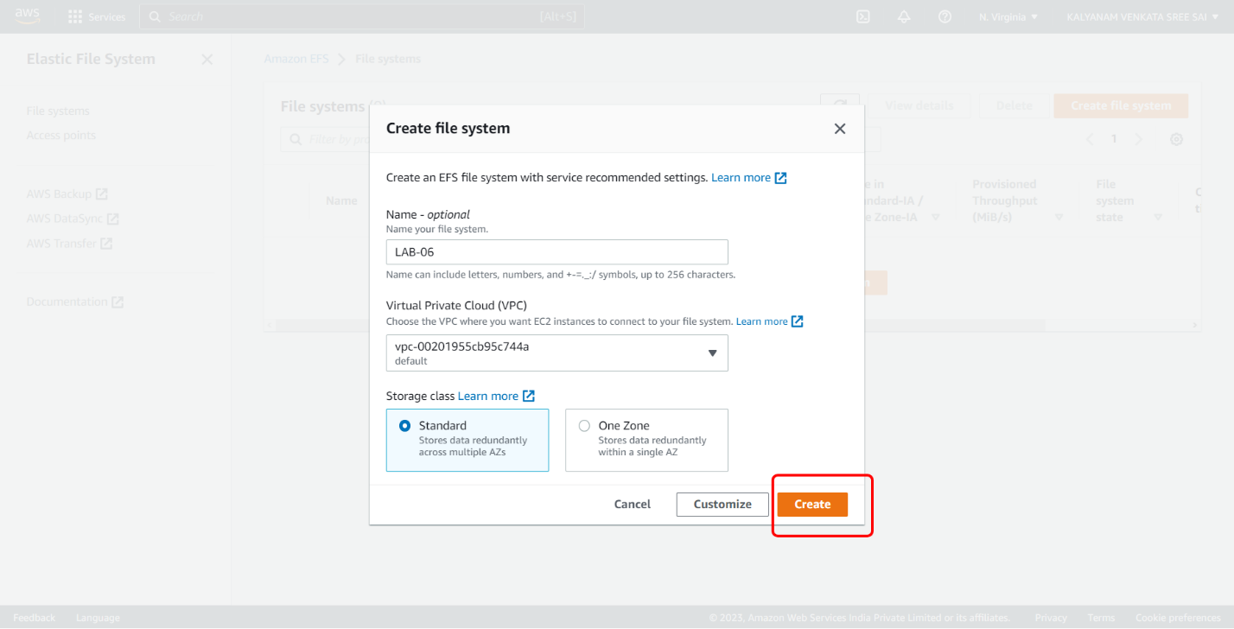

Step-12: When clicking on your file system ID or file system name, it takes you to the details page of your EFS.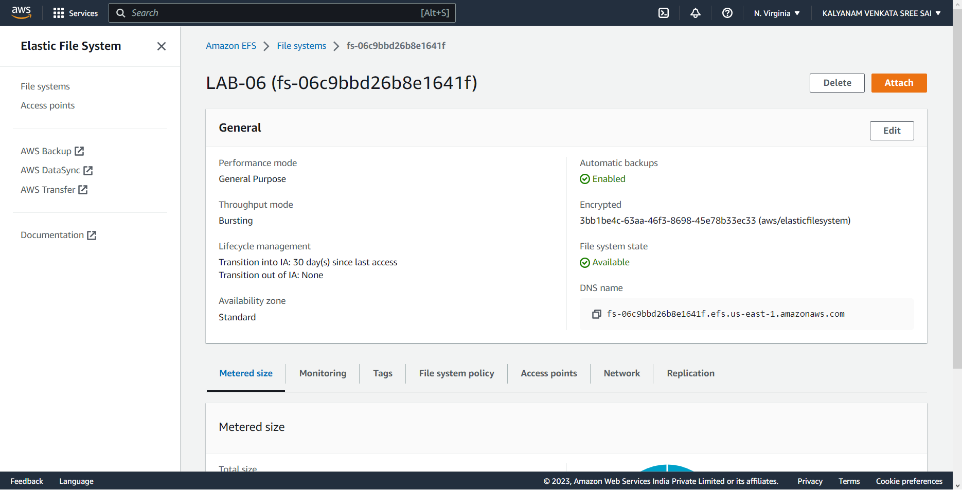

**Attaching an EFS to an EC2 Instance.**

You have two ways to mount the EFS:

1) At the moment of launching a new instance

2)On a running instance, using bash commands with the help of the amazon-efs-utils library.

In this we are using 1st step i.e. new instance creation.

Step-1: Go through the search bar and type “EC2”.

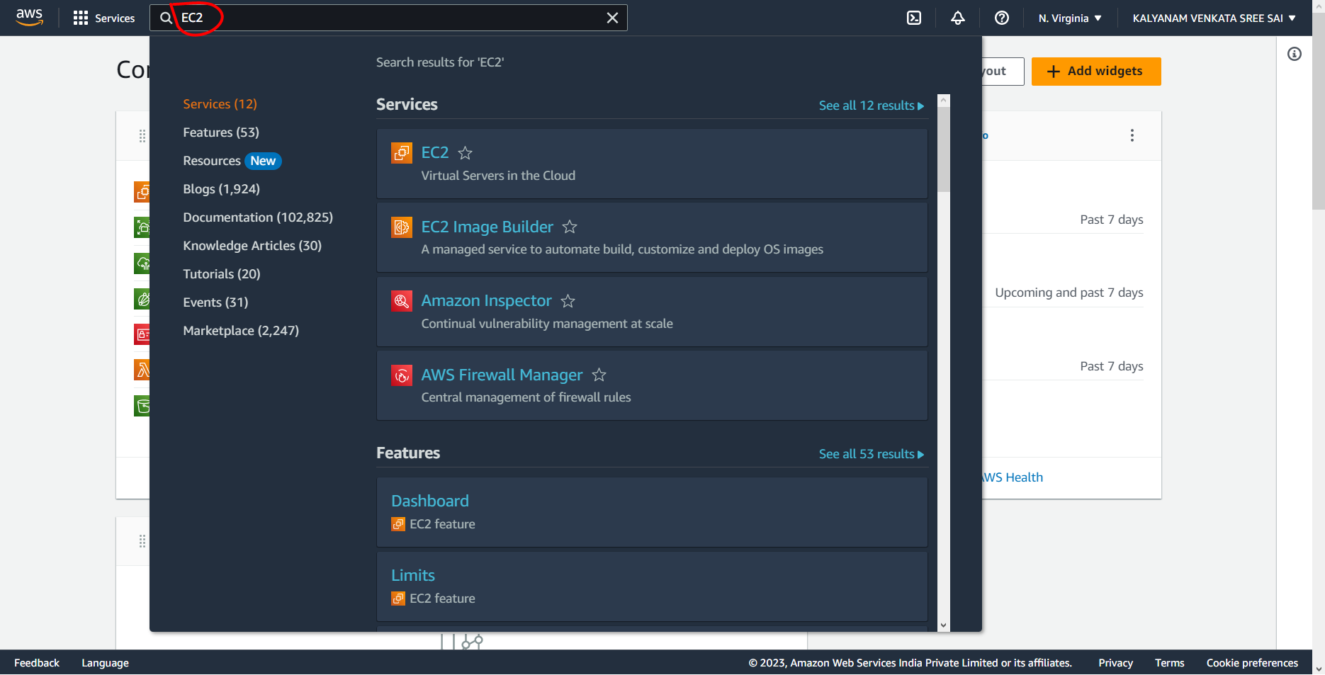

Step-2: Select the First service from the listed below.

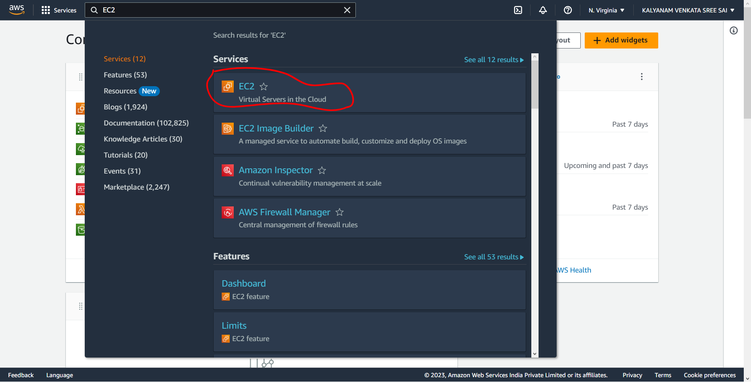

Step-3: After clicking the First Service The console will look like.

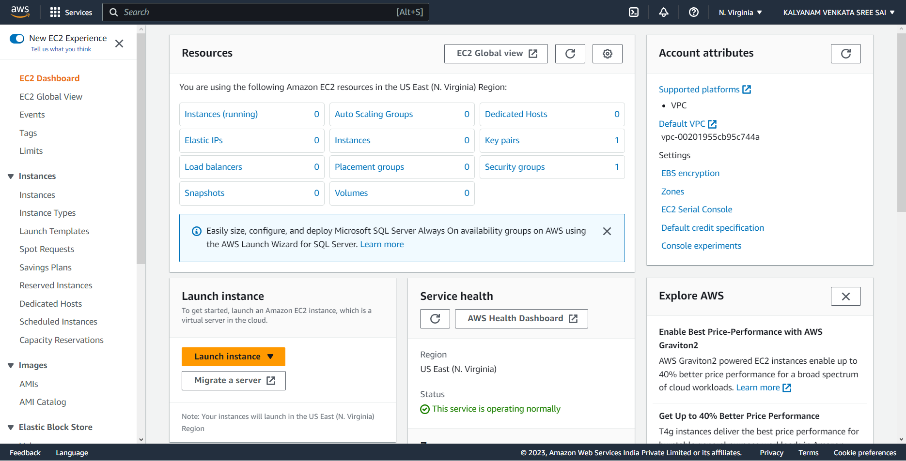

Step-4: Click on the “Lunch Instance” in the EC2 Console.

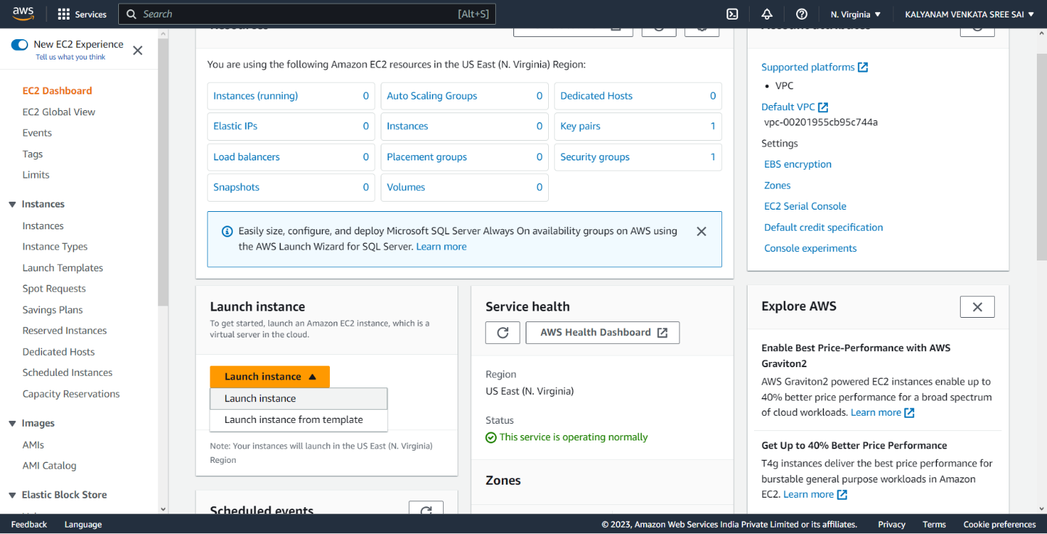

Step-5: Click on the “Launch Instance” from the drop-down menu.



Step-6: After Clicking on the Launch Instance, it will look like.

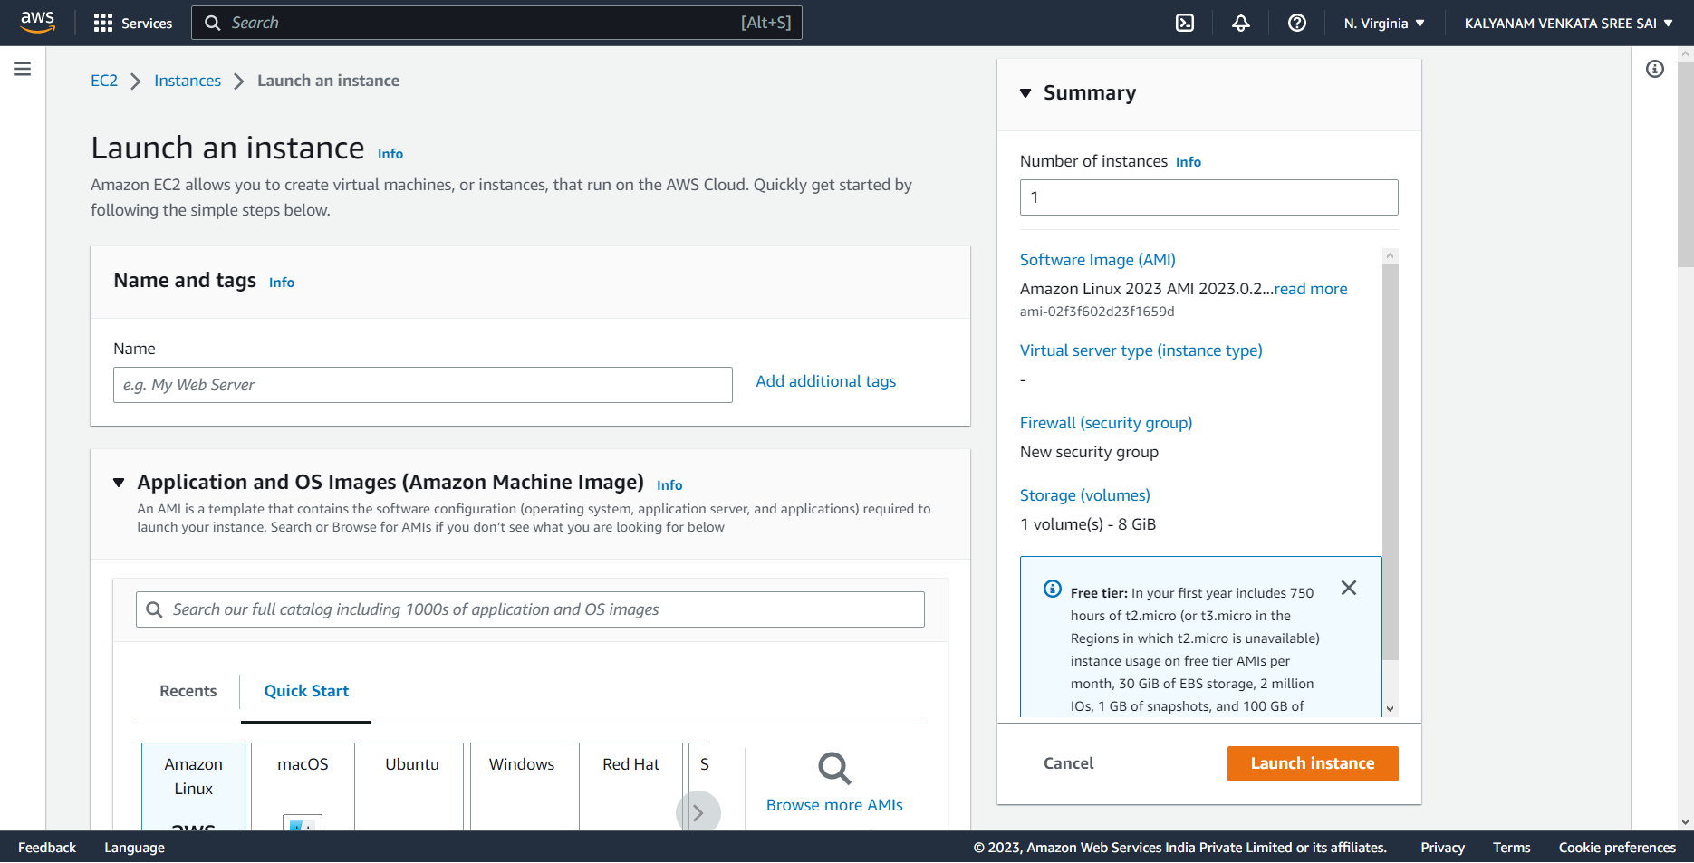

Step-7: In the Network settings Click the Edit option.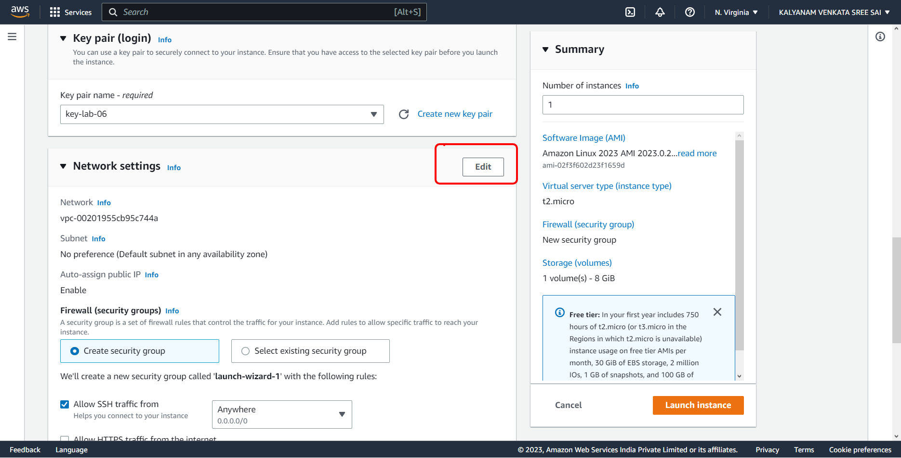

Step-8:Select the Subnet Region which is same to EFS region.

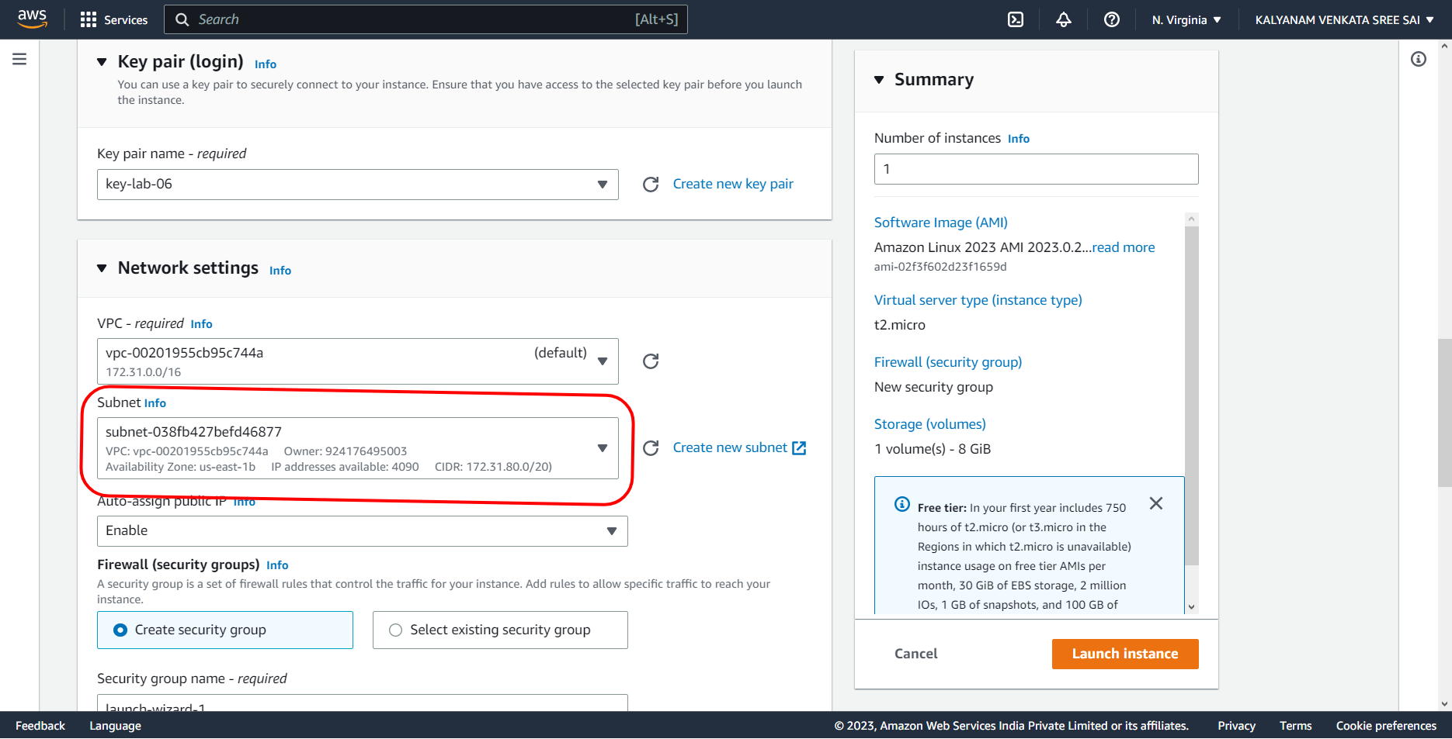

Step-9: click the edit option in Configuration storage.

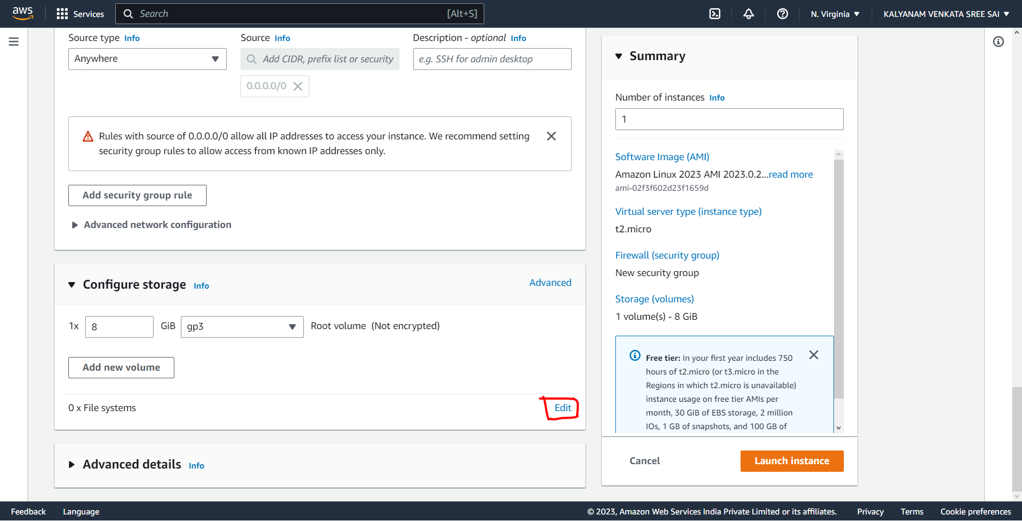

Step-10: Select the “EFS”.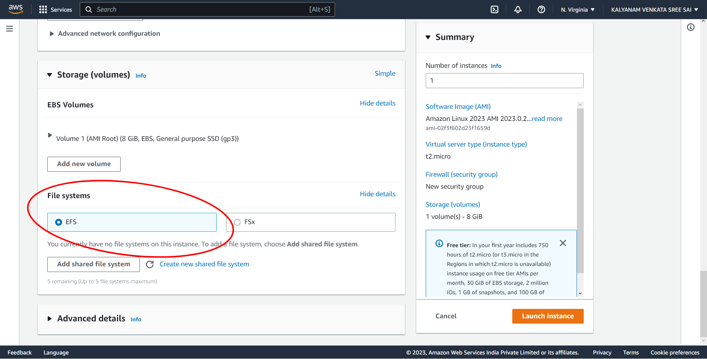

Step-11: Click the “Add shared file system”.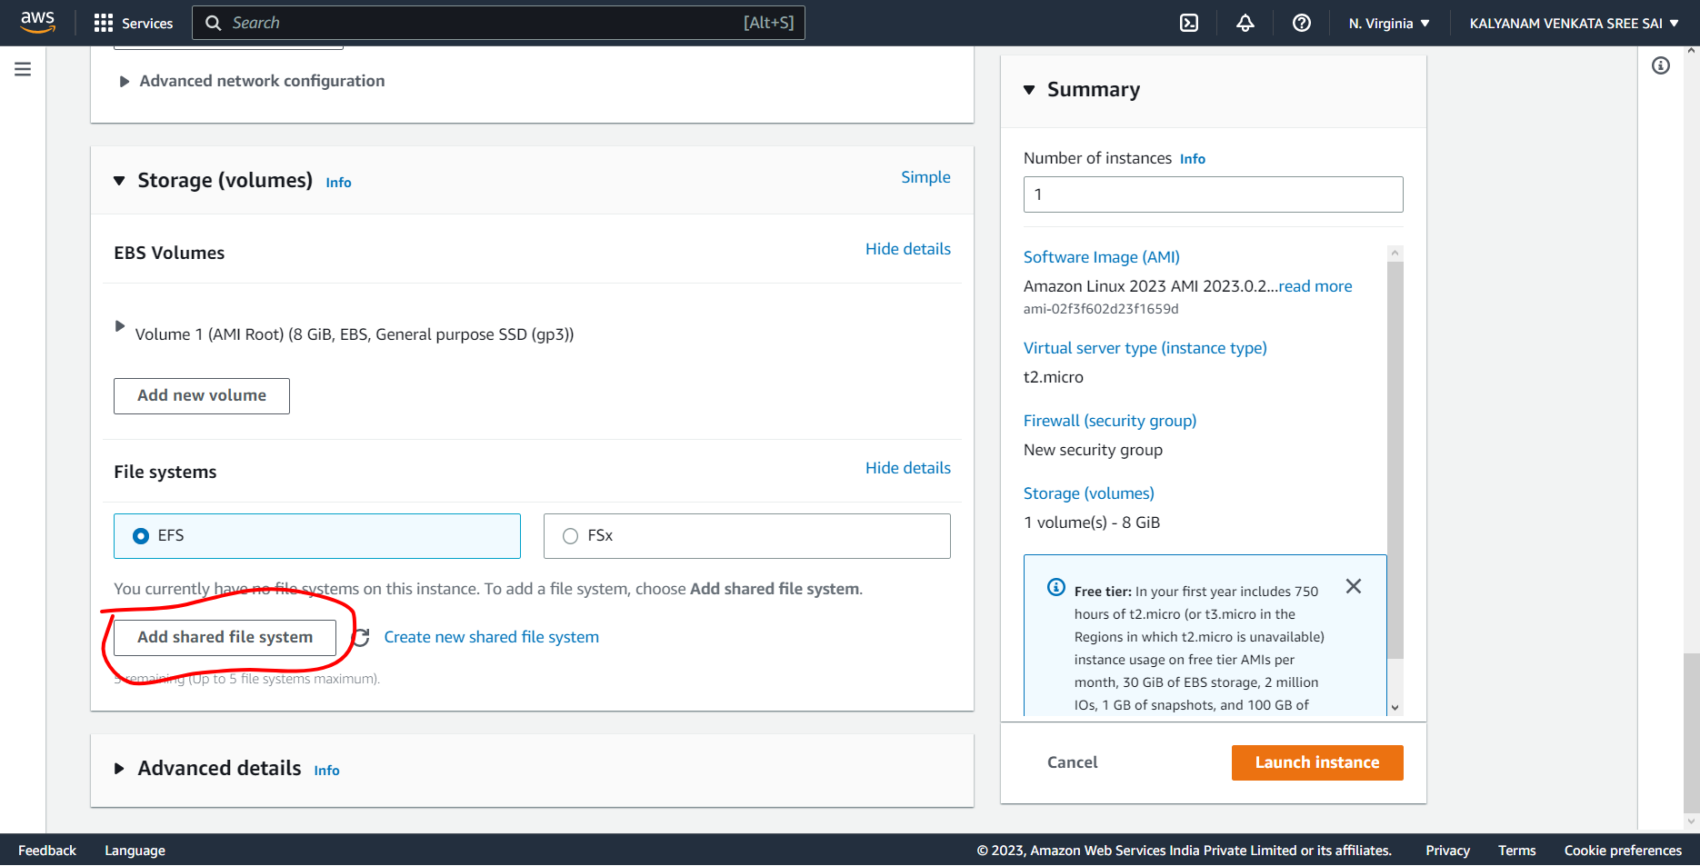

Step-12: Automatic it will select the available file system. 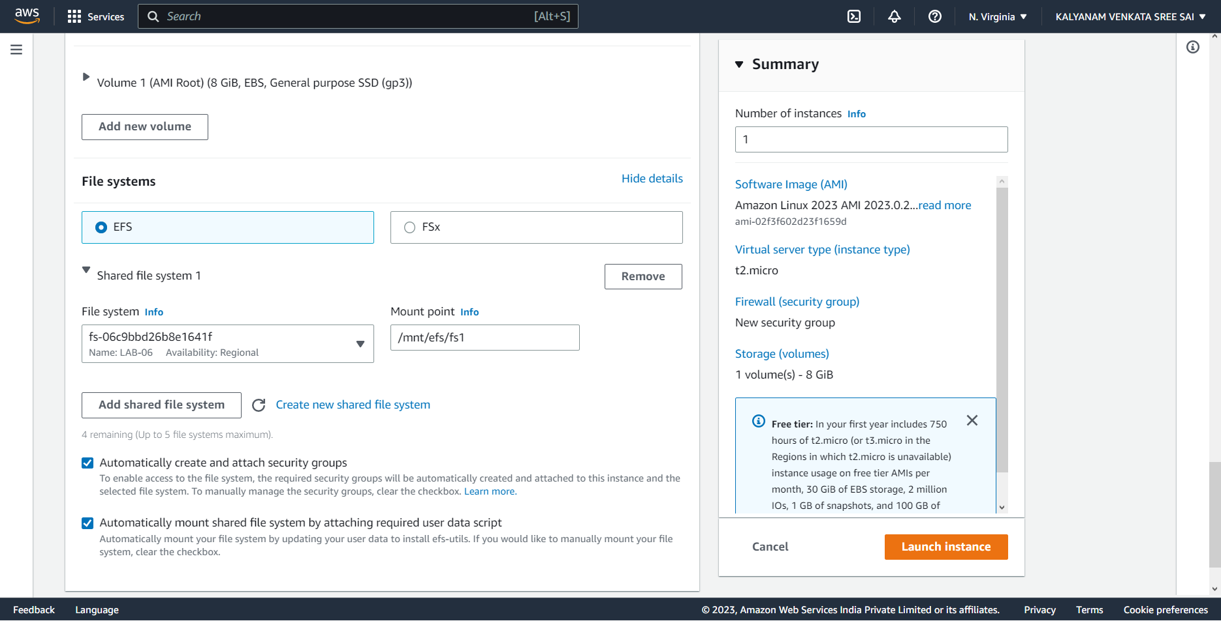

Step-13:click the launch instance.

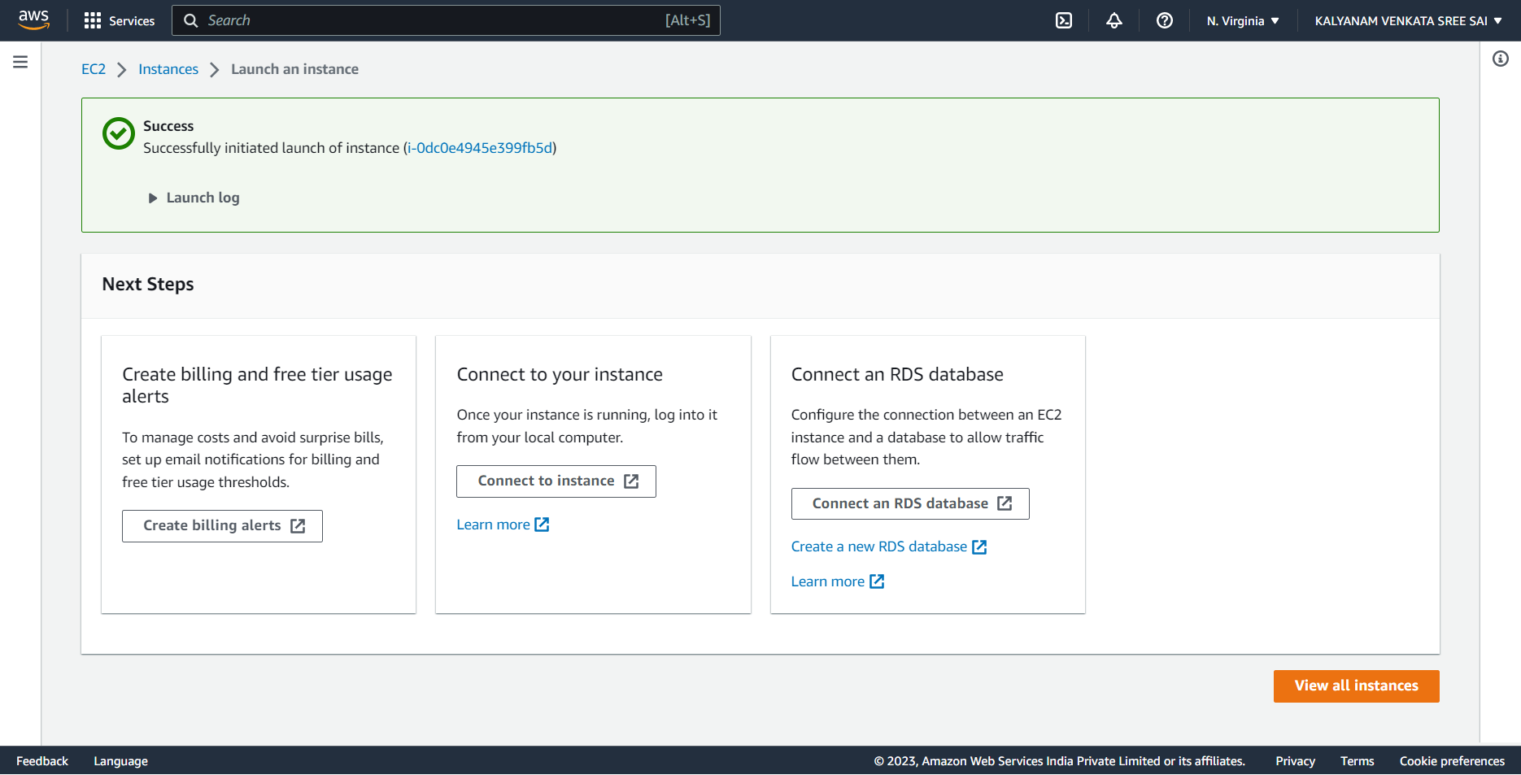

Step-14: Now Connect the instance.

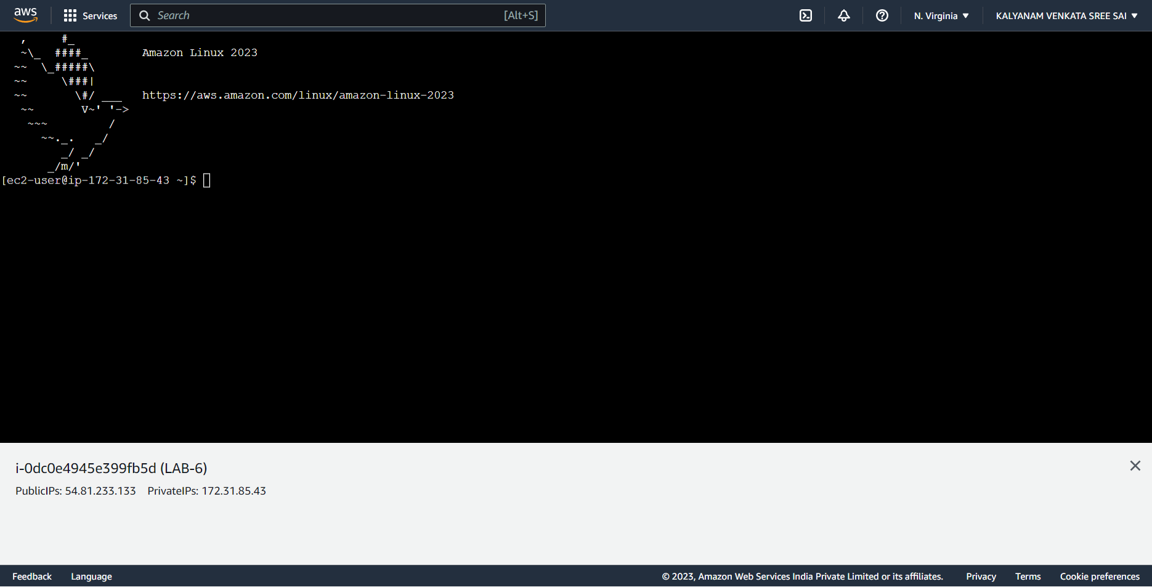

Step-15: Finally we have sucessful mounted the EFS.